Nick Scott
CS-330
Professor Bishop
10/25/26
Final Project: Reflection
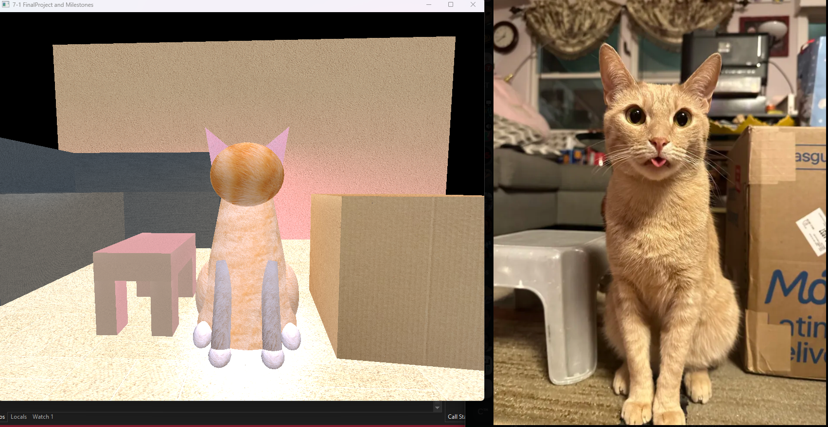
Four objects were chosen to recreate the 3D scene I selected for my final project. Firstly, the main focus of the image, my cat Toby, was chosen to be the primary point of interest. The other objects were chosen to frame my cat and create a basic living room scene, showing both his relative size and position to common everyday objects. The cardboard box, sitting to his left, and the plastic stool, sitting to his right, show how big he is compared to objects we deal with every day. Lastly, the couch helps frame the overall living room scene by creating dimension in the living room space. These objects fulfill the required functionality by being composed of multiple primitive shapes (except for the cardboard box).
While the initial placement for objects were based on educated guesses for the XYZ positions, objects like the couch and the stool were easier to calculate due to their symmetry and shape. For example, after the first leg of the stool was placed, I could easily calculate the rest of the XYZ coordinate values for the legs and stool based on the scale I set each shape to, without needing to guess. To an extent, even creating the cat involved designing “one half” of his body, then using symmetry to set up the other half.
Like many camera controls found in video games and computer applications, a keyboard and mouse is used to control the camera in the scene. The WASD control scheme was used to set up the camera, controlling forward, left, right, and backward directions. Q and E are used to traverse upward and downward, respectively. The user can use the mouse to look around, and the scroll wheel to control the speed. Those who have controlled a camera in another application with a keyboard and mouse should find the controls to be intuitive.
Custom functions, such as Mouse_Position_Callback(), Mouse_Scroll_Callback(), and ProcessKeyboardEvents(), were each used to process the inputs that the user conducts during the application. These functions help organize the program in such a way so that it clearly defines how each type of input should manipulate the scene. For example, Mouse_Position_Callback() is called whenever the mouse position changes within the window. It tells the camera to rotate in such a way so that the user can feel they are looking around within the scene. The function is helpful so that it can be reused every time the mouse changes position, rather than needing to be called every frame and checking the current mouse position compared to the previous frame’s position.
Likewise, ProcessKeyboardEvents() runs if-statements to determine how the camera should move based on the current keys being pressed. By calling this helper function within PrepareSceneView(), the function is cleaner by redirecting the program to the specialized method. Additionally, if bugs were to arise with the keyboard, it would be easier to find the location to fix, rather than needing to comb through the entire PrepareSceneView() if the helper function weren’t used. Additionally, these helper functions are not locked into this program. If they were reused in another OpenGL application, the control scheme would still work independently of this cat-specific scene.

